INDIVIDUAL MODULE-WISE LAB WORKBOOK
Robot Framework & PyTest Practical Assignments

Item | Details
Module | Robot Framework & PyTest
Language | Python
Browser | Google Chrome
Automation | Robot Framework / SeleniumLibrary / Selenium WebDriver
Test Framework | PyTest
Reporting | Robot output.xml / log.html / report.html; pytest-html
Experiments / Assignments | Robot Framework topics 1–7; PyTest Assignments 7–9
Project evidence | Command-line runs, RIDE, browser execution, project tree, source code, CSV and HTML report

Module Focus: Robot Framework syntax, browser automation, variables, custom keywords, assertions, setup and teardown, tags, parallel execution, reports and RIDE, CSV-driven Robot testing, followed by PyTest POM, data-driven testing and HTML reporting.

Module Overview
This workbook has been reorganized to follow the structure of the provided Automation with Selenium lab workbook. Each practical item uses the same evaluation-friendly sequence: Problem Statement, Objective, Tools/Concepts, Implementation Steps, Source Code or Implementation, Output/Screenshots, Expected Output, Result and Observation, and Conclusion.
Section | Coverage
Robot Framework — Experiment 1 | Environment setup and tools
Robot Framework — Experiment 2 | Basic syntax and SeleniumLibrary keywords
Robot Framework — Experiment 3 | Variables and data-driven automation
Robot Framework — Experiment 4 | Custom keywords, BuiltIn operations and Python library
Robot Framework — Experiment 5 | Assertions and controlled failure
Robot Framework — Experiment 6 | Test setup and teardown
Robot Framework — Experiment 7 | Tags, command-line execution, Pabot parallel execution
Robot Framework — Reports | Reports, logs and RIDE
Robot Framework — Data Driven | CSV-driven login validation
PyTest — Assignment 7 | Page Object Model
PyTest — Assignment 8 | Data-Driven Testing
PyTest — Assignment 9 | HTML reporting and failure screenshots
Practical record note: the Robot Framework source documentation records a real organized suite of 7 passed tests and a separate Pabot run of 4 passed tests. The later PyTest work was rerun in the current workspace and the supplied current evidence shows 10 passed in the final combined suite.

Environment and Software
Component | Verified version / value
Python | 3.14.3
pip | 26.2.1
Robot Framework | 7.5
Selenium | 4.49.0
SeleniumLibrary | 6.9.0
RIDE | 2.2.4
PyTest | 9.1.1
pytest-html | 4.2.0
robotframework-pabot | 5.2.2
Robot project | C:\RobotFramework_Project (recorded Robot work)
Current PyTest workspace | D:\Personal Projects\ROBOT
The Robot Framework setup record states that the isolated environment was created at C:\RobotFramework_Project with a venv and that Python, pip, Robot Framework and RIDE were verified. The PyTest work was subsequently executed in the current D:\Personal Projects\ROBOT workspace.
cd C:\RobotFramework_Project
.\venv\Scripts\activate
python --version
python -m pip --version
robot --version

Experiment 1: Robot Framework Environment Setup

Problem Statement
Prepare an isolated Robot Framework environment containing the required Python packages, browser automation library and RIDE editor so that the remaining practical experiments can be executed consistently.

Objective
To create and verify the Robot Framework environment used for the practical work.

Tools, Software, and Concepts Used
• Python and pip
• Virtual environment
• Robot Framework
• SeleniumLibrary and Selenium
• RIDE
• Google Chrome

Implementation Steps
1. Create or enter the project directory.
2. Create and activate the virtual environment.
3. Verify Python and pip versions.
4. Verify the Robot Framework installation.
5. Launch RIDE and verify that the environment is available.

Execution
cd C:\RobotFramework_Project
.\venv\Scripts\activate
python --version
python -m pip --version
robot --version

Output / Screenshots
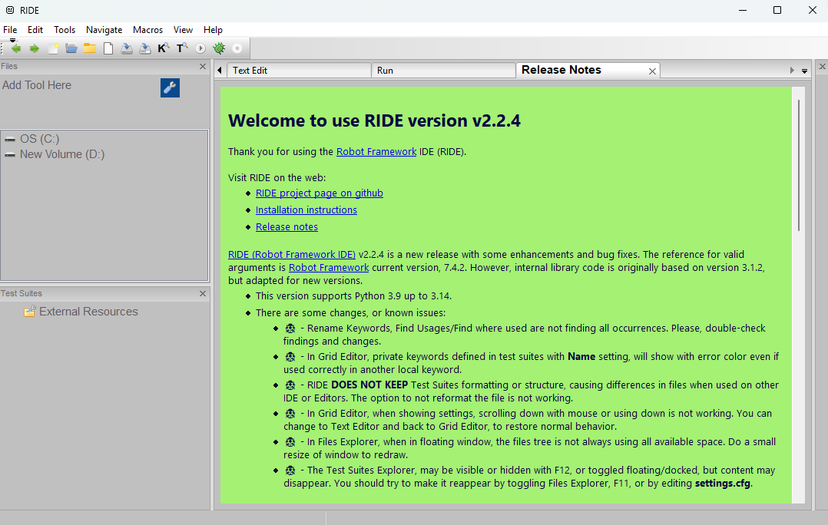
Screenshot 1: RIDE environment launched during setup verification.

Expected Output
Python, pip and Robot Framework version commands should complete successfully, and RIDE should launch.

Result and Observation
The setup commands were executed successfully. RIDE 2.2.4 was also launched during setup verification.

Conclusion
The isolated Robot Framework environment was prepared and verified for the practical exercises.

Experiment 2: Basic Syntax and SeleniumLibrary Keywords

Problem Statement
Create a Robot Framework browser test that opens a web page, navigates to a URL, enters search text, verifies an element and closes the browser.

Objective
To demonstrate Robot Framework sections, SeleniumLibrary browser keywords, navigation, input and verification.

Tools, Software, and Concepts Used
• Robot Framework
• SeleniumLibrary
• Open Browser / Go To
• Input Text
• Page Should Contain Element
• Resource files
• Google Chrome

Implementation Steps
1. Load the reusable browser resource.
2. Open the search browser.
3. Navigate to the configured search URL.
4. Enter the configured search text.
5. Verify the search element.
6. Close the browser.

Source Code
*** Settings ***
Resource ${EXECDIR}${/}robot_resources${/}browser.resource
*** Test Cases ***
Open Navigate Input And Verify
Open Search Browser
Go To ${SEARCH_URL}
Search Google ${SEARCH_TEXT}
Close Search Browser
The reusable browser keyword uses SeleniumLibrary operations including Open Browser, Go To, Input Text and Page Should Contain Element. The example uses the locator name=q for the Google search field.

Output / Screenshots
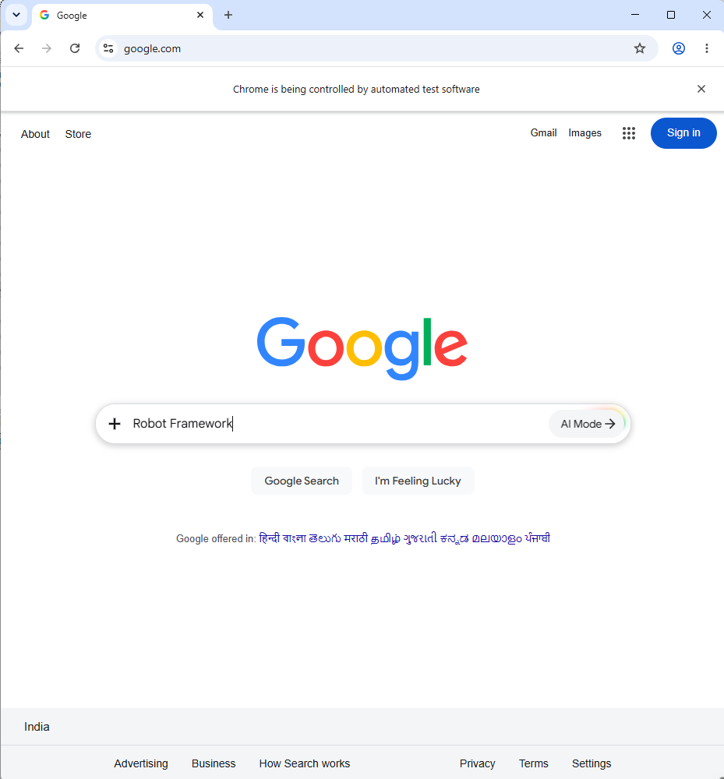
Screenshot 1: Browser opened for the Robot Framework search test.
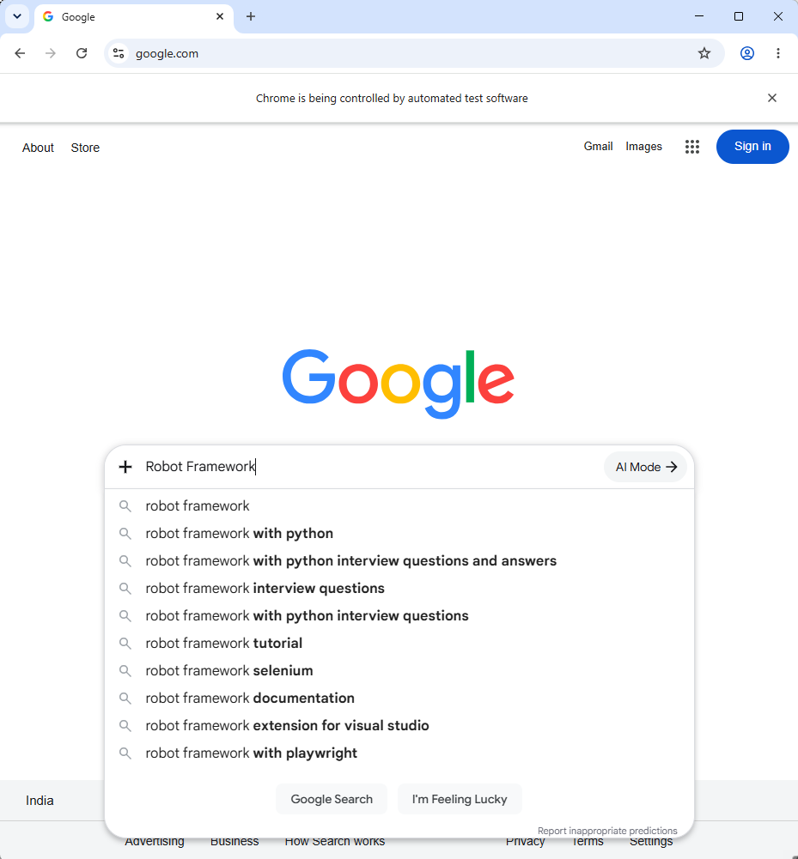
Screenshot 2: Search interaction/result in Chrome.
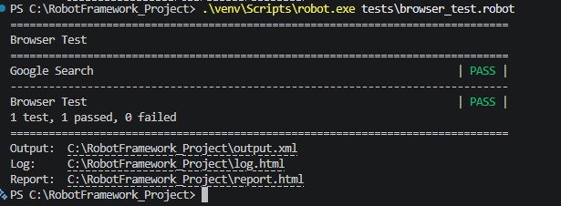
Screenshot 3: Command-line Robot Framework browser test — PASS.

Expected Output
The browser opens, the search text is entered, the expected element is found, and the test finishes with PASS.

Result and Observation
The organized Robot suite executed with 7 tests passed and 0 failed. The browser test also passed with Chrome.

Conclusion
Basic Robot Framework syntax and SeleniumLibrary browser keywords were implemented and verified.

Experiment 3: Variables and Data-Driven Automation

Problem Statement
Use reusable Robot Framework variables for browser configuration and test data, and use external data to execute the same validation logic against multiple datasets.

Objective
To use scalar variables for readable configuration and demonstrate external CSV-driven execution.

Tools, Software, and Concepts Used
• Scalar variables
• Resource files
• ${EXECDIR}
• CSV test data
• Robot Framework FOR loop
• External data utility

Variable Implementation
*** Variables ***
${BROWSER} chrome
${SEARCH_URL} https://www.google.com
${SEARCH_TEXT} Robot Framework
${WAIT_TIME} 2 seconds
${LOGIN_DATA} ${EXECDIR}${/}test_data${/}login_data.csv

Data-Driven Test Data
username,password,expected_result
valid_user,valid_password,success
invalid_user,valid_password,invalid_username
valid_user,invalid_password,invalid_password
invalid_user,invalid_password,invalid_credentials

Implementation Steps
1. Define reusable variables in variables.resource.
2. Pass the search text to the reusable browser keyword.
3. Define the CSV path relative to the project.
4. Read the CSV rows using the Robot custom library.
5. Loop through each dataset and compare actual and expected results.

Robot Data-Driven Logic
${cases}= Read Login Cases ${EXECDIR}${/}test_data${/}login_data.csv
FOR ${case} IN @{cases}
${actual_result}= Validate Login ${case}[username] ${case}[password]
Should Be Equal As Strings ${actual_result} ${case}[expected_result]
Log ${case}[username] / ${case}[password] -> ${actual_result}
END

Output / Screenshots
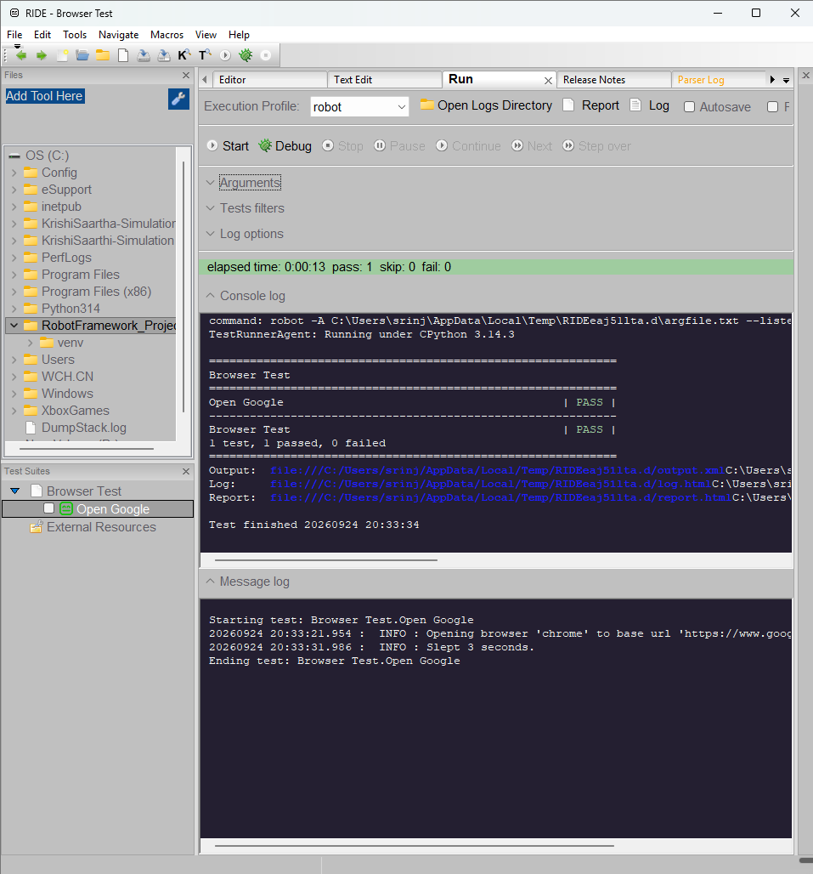
Screenshot 1: Robot Framework/RIDE execution evidence for the organized project.
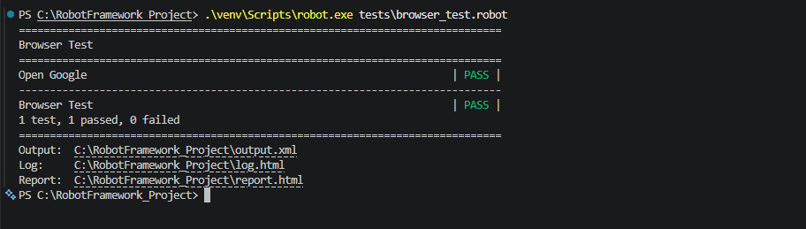
Screenshot 2: Command-line execution evidence from the practical record.

Expected Output
Variables are substituted at execution time and each of the four CSV datasets is processed by the same test logic.

Result and Observation
Variable substitution was observed in RIDE and command-line execution. The organized suite passed 7 tests, and the Robot data-driven test processed all four datasets.

Conclusion
Reusable variables and external CSV-driven Robot testing were implemented and verified.

Experiment 4: Custom Keywords, BuiltIn Operations and Libraries

Problem Statement
Improve test readability by creating user-defined Robot Framework keywords with arguments and demonstrate BuiltIn operations for arithmetic and string manipulation.

Objective
To create readable reusable keywords and demonstrate BuiltIn mathematical and string operations.

Tools, Software, and Concepts Used
• User-defined keywords
• Keyword arguments
• BuiltIn Evaluate
• Should Be Equal As Integers
• Convert To Upper Case
• Python custom library

Custom Keyword
*** Keywords ***
Search Google
[Arguments] ${search_text}
Input Text name=q ${search_text}
Page Should Contain Element name=q

BuiltIn Examples
*** Test Cases ***
BuiltIn Example
${result}= Evaluate 10 + 20
Should Be Equal As Integers ${result} 30
BuiltIn String Example
${text}= Set Variable robot framework
${upper_text}= Convert To Upper Case ${text}
Should Be Equal As Strings ${upper_text} ROBOT FRAMEWORK

Python Library Role
The project also contains robot_resources/login_data_library.py, which exposes CSV reading and local login validation keywords to Robot Framework.

Output / Screenshots
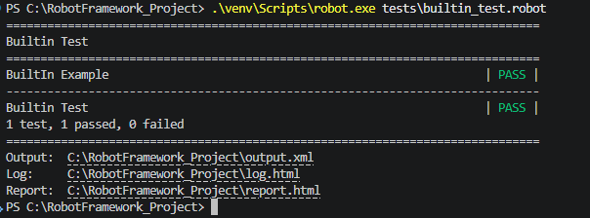
Screenshot 1: BuiltIn test execution — PASS.
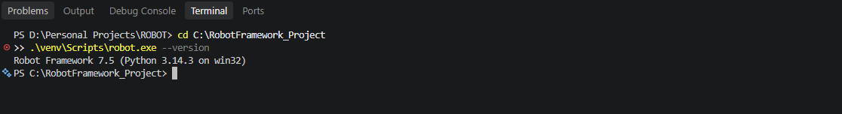
Screenshot 2: Robot Framework execution output from the practical record.

Expected Output
The arithmetic expression evaluates to 30, the string is converted to ROBOT FRAMEWORK, and the custom keyword accepts its search-text argument.

Result and Observation
The BuiltIn exercise was executed successfully. The expanded organized suite subsequently executed with 7 tests passed and 0 failed.

Conclusion
Custom keywords, arguments, BuiltIn arithmetic, string manipulation and a Python custom library were implemented.

Experiment 5: Assertions and Verification

Problem Statement
Perform a test action and compare the actual result with the expected result. Also demonstrate a controlled failing assertion so that failure reporting can be observed.

Objective
To verify expected-versus-actual behavior using Robot Framework assertions and document failure handling separately from the final passing suite.

Tools, Software, and Concepts Used
• Should Be Equal As Strings
• Set Variable
• Log
• Robot exit code
• Failure report
• Tags for controlled failure

Passing Assertion
${actual}= Set Variable success
Should Be Equal As Strings ${actual} success
Log Expected: success | Actual: ${actual}

Controlled Failure
${actual}= Set Variable wrong-value
Should Be Equal As Strings ${actual} expected-value

Execution Commands
cd C:\RobotFramework_Project
.\venv\Scripts\robot.exe --exclude demo-failure robot_tests\assertions
.\venv\Scripts\robot.exe --include demo-failure --outputdir reports\failure_demo robot_tests\assertions\assertion_failure_demo.robot

Output / Screenshots
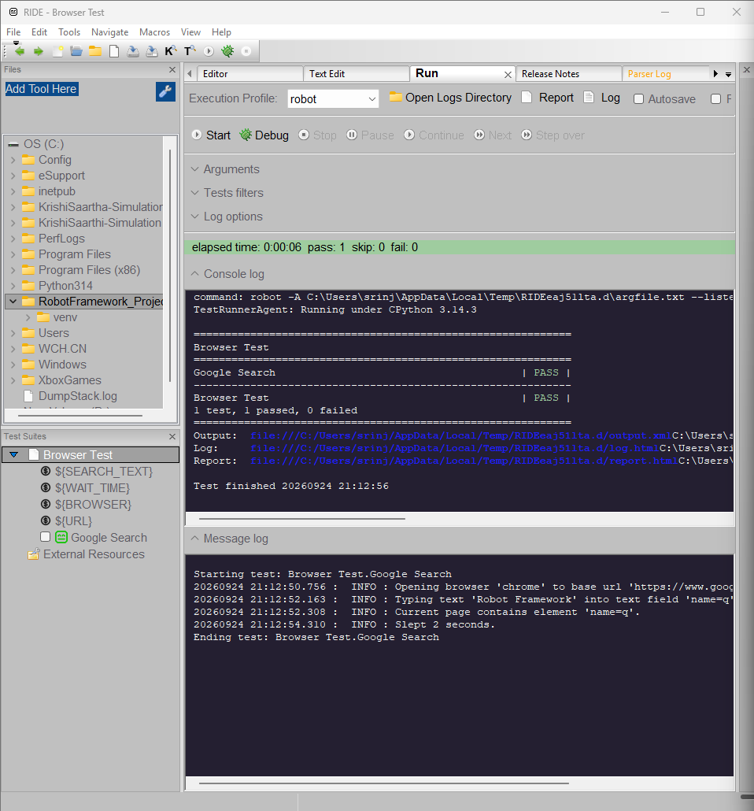
Screenshot 1: RIDE/IDE execution evidence for Robot Framework assertions.
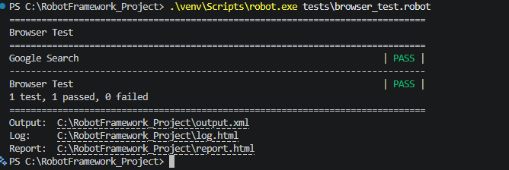
Screenshot 2: Command-line Robot execution — PASS.

Expected Output
The passing assertion should complete successfully. The deliberate failure should report the mismatch wrong-value != expected-value and return exit code 1.

Result and Observation
The passing assertion suite was included in the 7-test passing run. The deliberate failure produced the actual mismatch message and exit code 1. It was excluded from the final passing suite.

Conclusion
Robot Framework assertions and controlled failure reporting were verified without presenting the intentional failure as a final suite failure.

Experiment 6: Test Setup and Teardown

Problem Statement
Create a test suite with common browser initialization and cleanup so that test cases can share a controlled browser lifecycle.

Objective
To control browser initialization, test preparation, logging and cleanup using suite-level and test-level setup/teardown.

Implementation
*** Settings ***
Suite Setup Open Search Browser
Suite Teardown Close Search Browser
Test Setup Log Starting browser lifecycle test
Test Teardown Log Browser lifecycle test finished

Implementation Steps
1. Configure suite setup to open the browser.
2. Configure suite teardown to close all browsers.
3. Add test setup logging.
4. Add test teardown logging.
5. Run the lifecycle suite and verify cleanup.

Execution
cd C:\RobotFramework_Project
.\venv\Scripts\robot.exe --outputdir reports\robot robot_tests\setup_teardown

Output / Screenshots
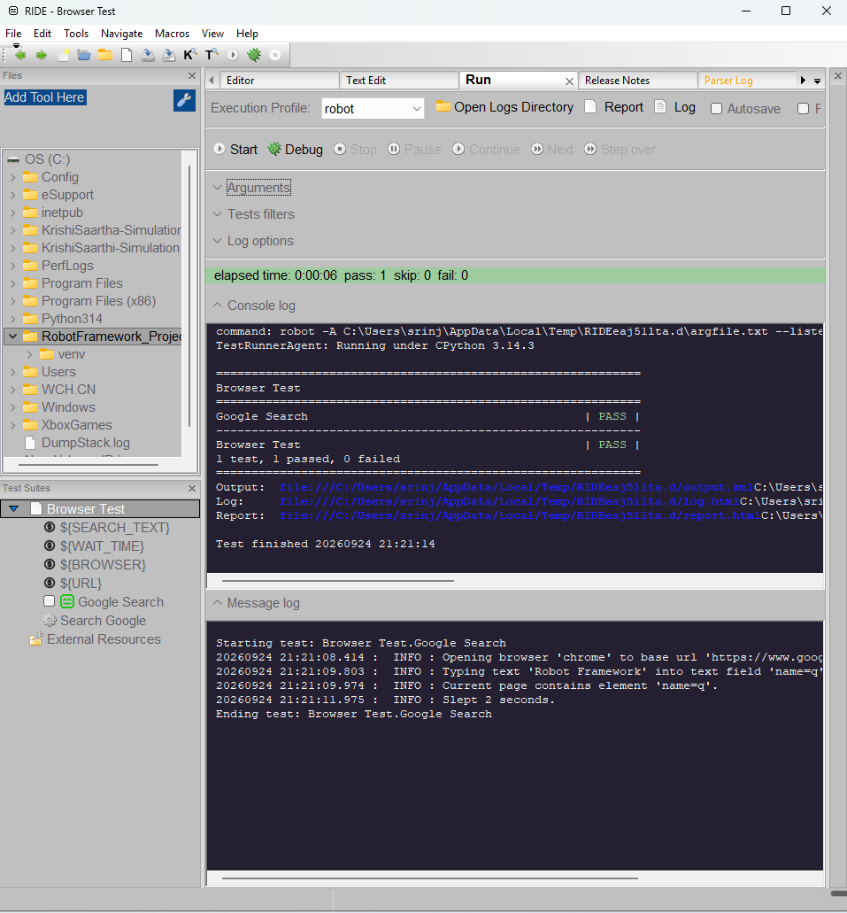
Screenshot 1: RIDE/IDE lifecycle execution evidence.
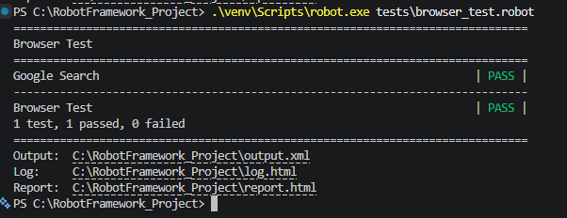
Screenshot 2: Command-line browser/lifecycle test — PASS.

Expected Output
The suite setup opens one browser before the tests, the test setup and teardown messages are logged, and suite teardown closes the browser after execution.

Result and Observation
The lifecycle test passed as part of the real 7-test Robot execution. Chrome opened and cleanup completed.

Conclusion
Suite-level and test-level setup/teardown were implemented with browser cleanup.

Experiment 7: Tags, Command-Line Execution and Parallel Execution

Problem Statement
Organize Robot Framework tests with tags, select tests from the command line, and execute independent suites in parallel.

Objective
To demonstrate test selection using include/exclude tags and parallel execution with Pabot.

Tags
cd C:\RobotFramework_Project
.\venv\Scripts\robot.exe --include smoke --outputdir reports\tags_include robot_tests\tags
.\venv\Scripts\robot.exe --exclude regression --outputdir reports\tags_exclude robot_tests\tags
The tagged suite contains smoke, fast and regression tags. The include and exclude commands each selected one test during verification.

Parallel Execution with Pabot
cd C:\RobotFramework_Project
$env:PATH = "$PWD\venv\Scripts;$env:PATH"
.\venv\Scripts\pabot.exe --processes 2 --exclude demo-failure --outputdir reports\parallel robot_tests\assertions robot_tests\tags

Output / Screenshots
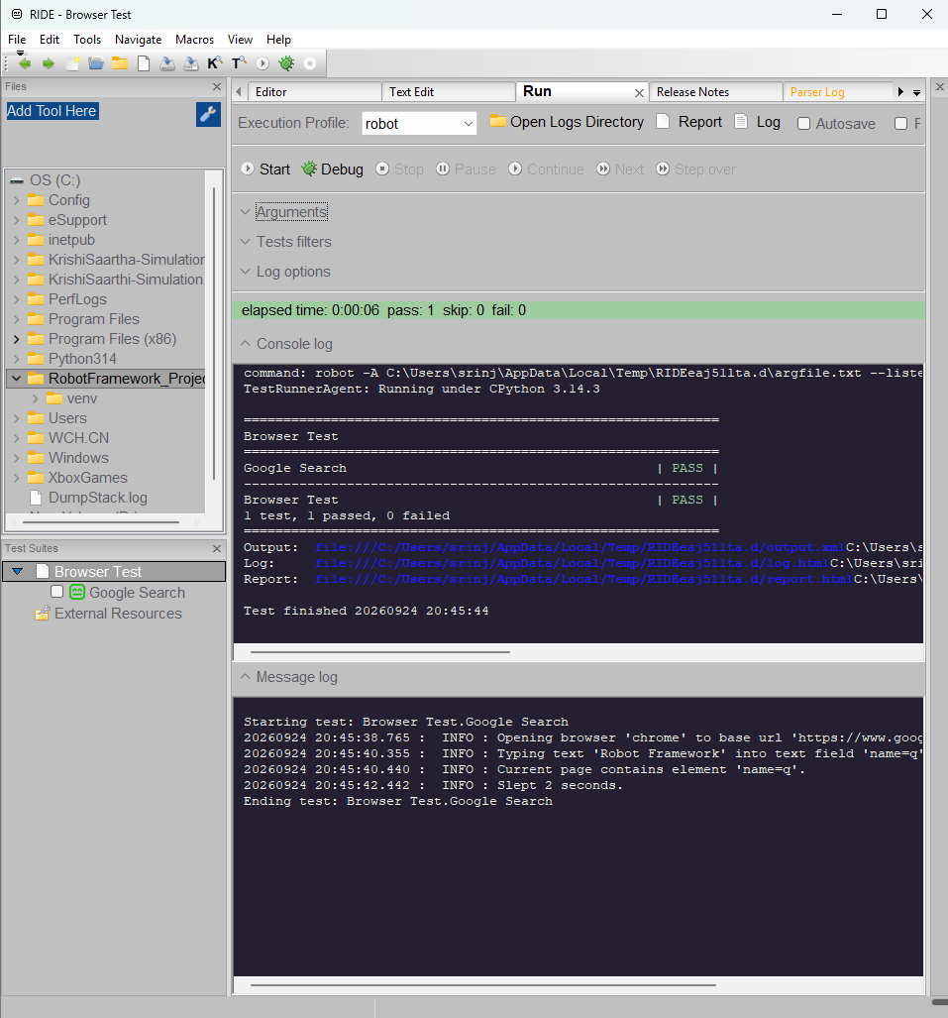
Screenshot 1: RIDE/IDE execution output for tagged/organized tests.
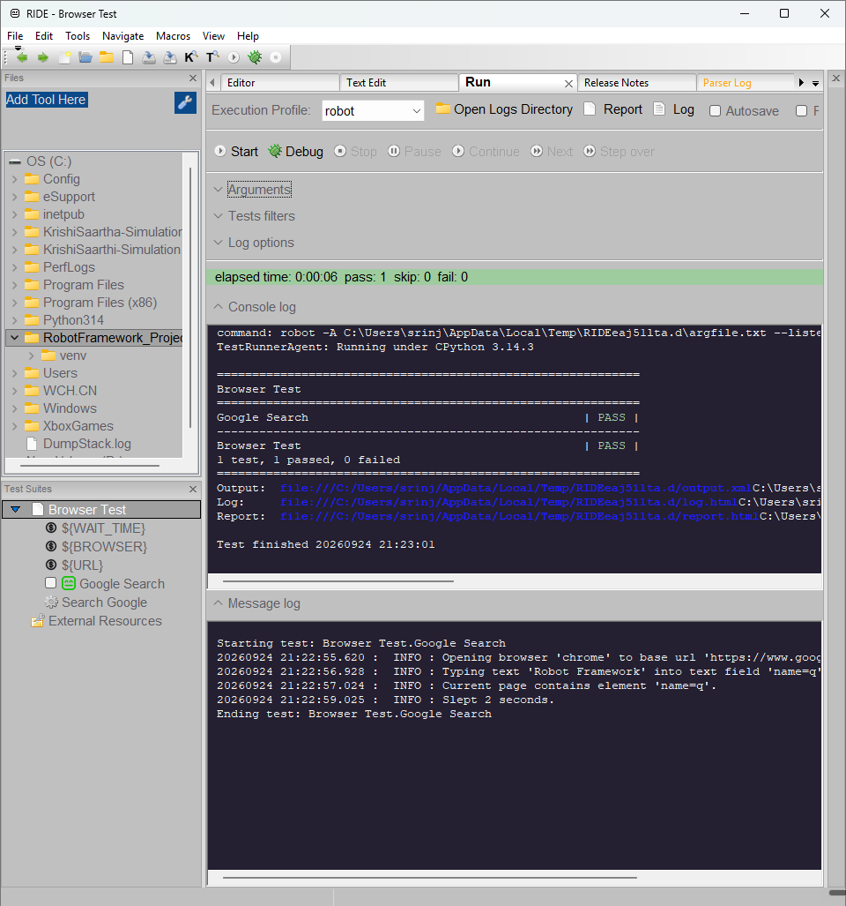
Screenshot 2: RIDE project/execution interface.

Expected Output
The include/exclude commands select the requested tagged tests. Pabot uses two processes and runs the independent suites without the intentional failure demo.

Result and Observation
Both tag-selection commands executed successfully. Pabot 5.2.2 ran the independent suites with two processes and reported 4 tests passed and 0 failed.

Conclusion
Tags, individual and directory execution, include/exclude selection, and parallel execution were verified.

Robot Framework Reports, Logs and RIDE

Objective
Explain the generated Robot Framework result files and demonstrate execution through RIDE as well as the command line.
File | Purpose
output.xml | Machine-readable execution results
log.html | Detailed keyword-level execution and failure information
report.html | Compact suite and test summary

Execution Command
cd C:\RobotFramework_Project
.\venv\Scripts\robot.exe --outputdir reports\robot --exclude demo-failure robot_tests

Output / Screenshots
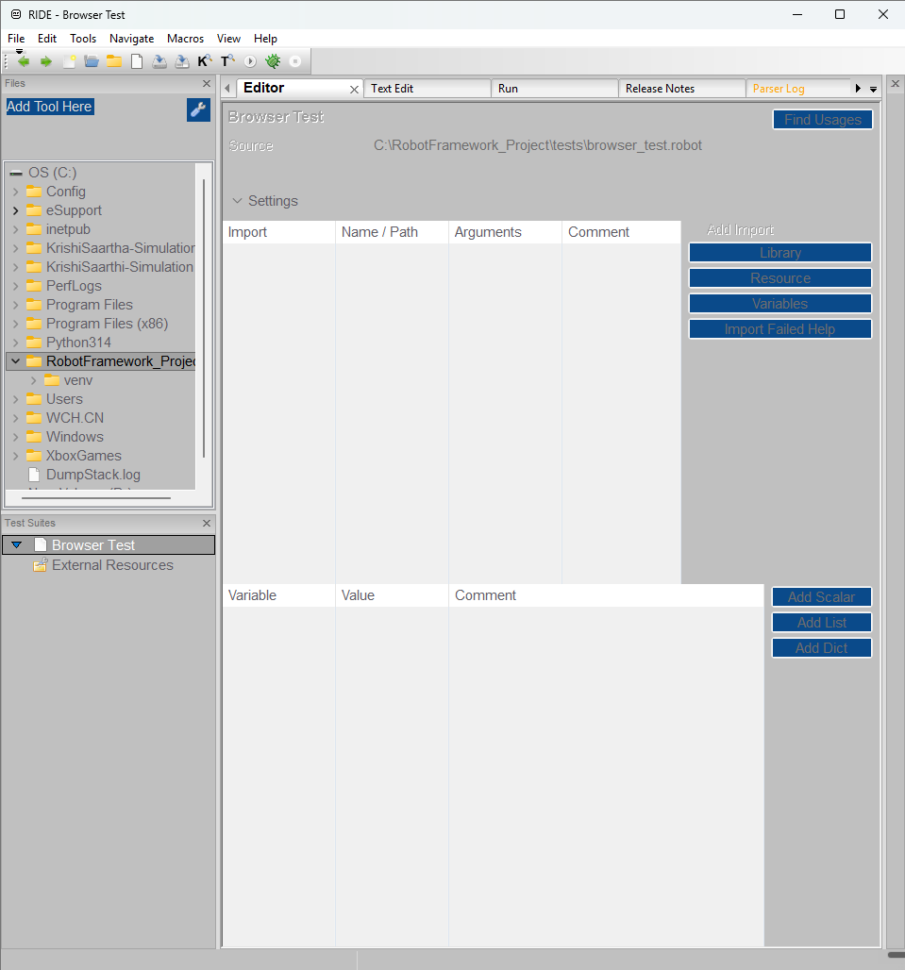
Screenshot 1: RIDE project/test interface used during the Robot Framework work.
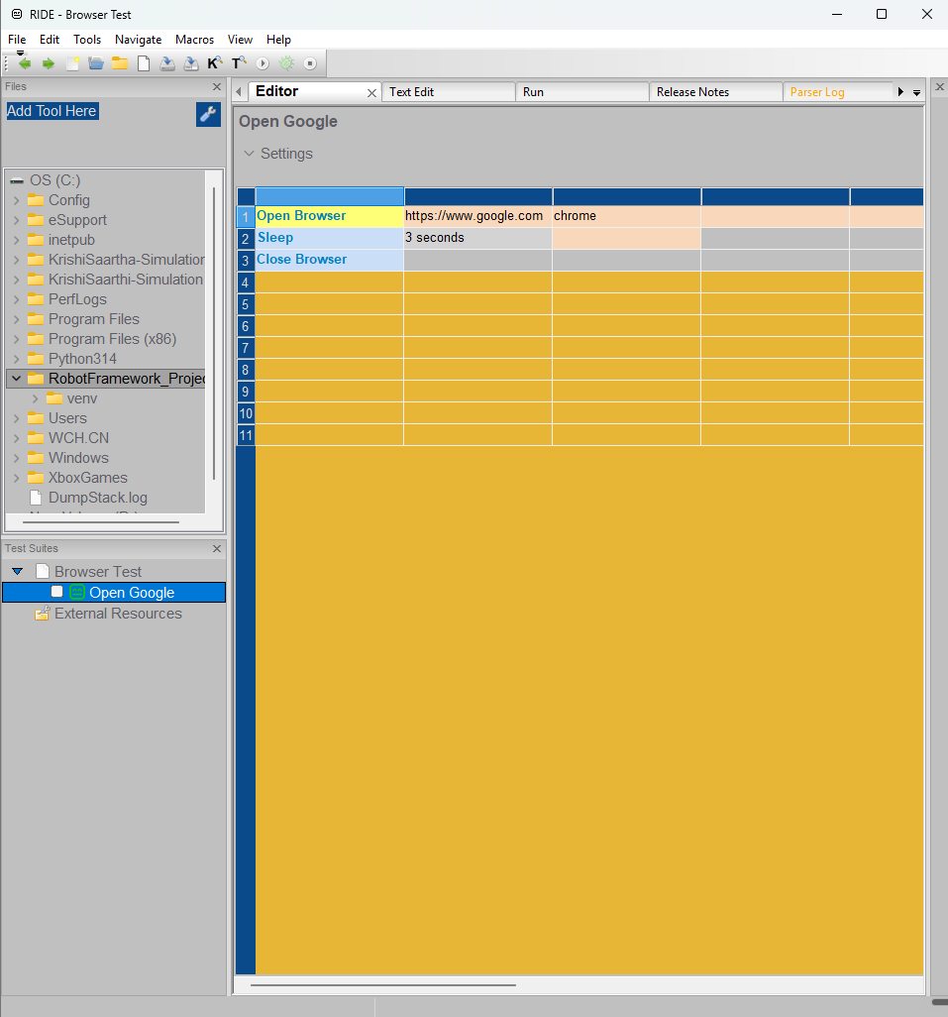
Screenshot 2: RIDE execution/results interface.

Expected Output
The command generates output.xml, log.html and report.html in the selected report directory.

Result and Observation
The command generated reports\robot\output.xml, log.html and report.html after the 7-pass run. RIDE 2.2.4 was launched and the browser test was run from RIDE with 1 test passed and 0 failed.

Conclusion
Robot reports, keyword logs and RIDE execution were verified.

Robot Framework Data-Driven Automation — Detailed Practical

Problem Statement
Execute identical login-validation logic against multiple external datasets instead of writing separate Robot test logic for every credential combination.

Objective
To read CSV data, repeat the same login validation for every row, log the result and compare the actual result with the expected result.

Test Data
Username | Password | Expected Result
valid_user | valid_password | success
invalid_user | valid_password | invalid_username
valid_user | invalid_password | invalid_password
invalid_user | invalid_password | invalid_credentials

Implementation
The project uses login_data_library.py to read the CSV and validate each row. The Robot test loops through the returned dictionaries.
${cases}= Read Login Cases ${EXECDIR}${/}test_data${/}login_data.csv
FOR ${case} IN @{cases}
${actual_result}= Validate Login ${case}[username] ${case}[password]
Should Be Equal As Strings ${actual_result} ${case}[expected_result]
Log ${case}[username] / ${case}[password] -> ${actual_result}
END

Execution
cd C:\RobotFramework_Project
.\venv\Scripts\robot.exe robot_tests\data_driven\login_data_driven.robot

Expected Output
All four CSV datasets are processed by the same Robot test logic and each actual result matches its expected result.

Result and Observation
The data-driven test passed in the real organized run. All four datasets were processed.

Conclusion
External CSV reading, repeated datasets, useful logs and expected-result verification were implemented.

